Final Business Analytics Project Report Template (Spring 2025)

Title Page
Name : Omar Noussier
Project Title: Customer Trends Behavior
Course: CAI3801.003
Semester: Spring 2025

Part 1: Business Problem and Objectives
- Business Domain: E-Commerce/Customer Analytics
- Problem Statement: Finding trends that point to client attrition in an online retail setting is the main commercial challenge. The goal of this project is to use analytics to find out which actions are the best indicators of client loss.
-Business Questions:
- How do purchase frequency and discount usage correlate with retention?
- What customer segments are most likely to churn?
- What product categories are most affected by churn?
- What strategies can the company use to retain high-value customers?
- What customer behaviors indicate a high risk of churn?
- What it is Matter:
Customer retention is vital for long-term profitability. Losing customers leads to increased marketing costs and reduced lifetime value. By identifying churn risks early, e-commerce companies can proactively engage vulnerable customers, personalize offers, and optimize marketing efforts.

Part 2: Data Source and Preparation
- Data Source(s): The dataset was sourced from Kaggle under the title “E-Commerce Data.” It contains real-world transactional data from an online retailer, offering insights into customer purchases, order frequency, product categories, and discount behavior. Kaggle is a reputable platform for datasets commonly used in data science projects.
- Dataset Summary: The dataset includes transactional data with 51,290 rows and 16 columns. Key fields include Sales, Profit, Discount, Customer ID, Gender, Product Category, Device Type, and Order Date. These fields provide the foundation for exploring customer behavior, sales trends, and churn risk.
- Data Cleaning & Preparation (Checkpoint 1): Missing values were found and dealt with appropriately. For instance, data types for Order Date were changed to datetime format for time-series analysis, and rows lacking Customer ID were eliminated. They created new features like Average Discount Rate and Total Revenue. Boxplots were used for visual inspection of sales and profit figures, and interquartile range filtering was used to exclude outliers.

Part 3: Diagnostic & Predictive Analytics

- Combo Chart (Profit vs. Sales by Product Category):
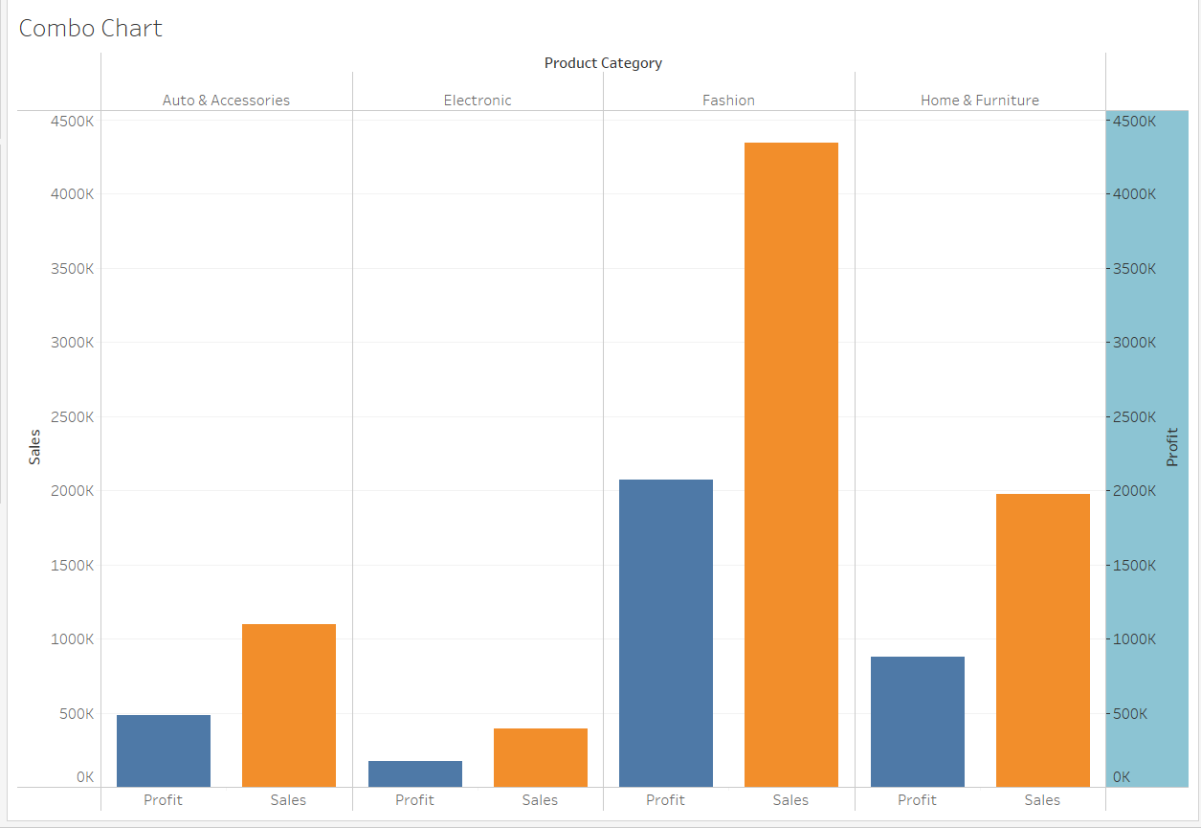
• Fashion category significantly outpaces other categories both in sales and profit, indicating it's the leading segment.
• Electronics show the lowest profitability, highlighting an area for strategic improvements or reconsideration in pricing strategies.
• Auto & Accessories and Home & Furniture maintain moderate profitability relative to sales.

- Cluster Chart (Sales vs. Profit):
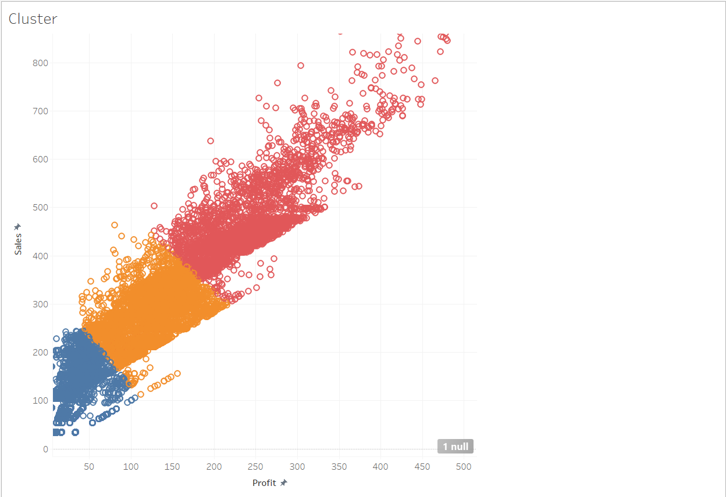
Clearly identify three segments of products based on profitability and sales volume:
- Red Cluster: High-profit, high-sales products; crucial to sustain marketing efforts.
- Orange Cluster: Medium-profit and sales; potential for targeted improvements.
- Blue Cluster: Lower-profit and sales products; opportunities exist to either optimize or reconsider their market strategy.
- Calculated Field:

• Likely represents a summary measure such as total sales or adjusted profit, providing an aggregate benchmark for overall business performance.

- Parameter + Calculated Field (Adjusted Profit vs. Profit by Product Category):
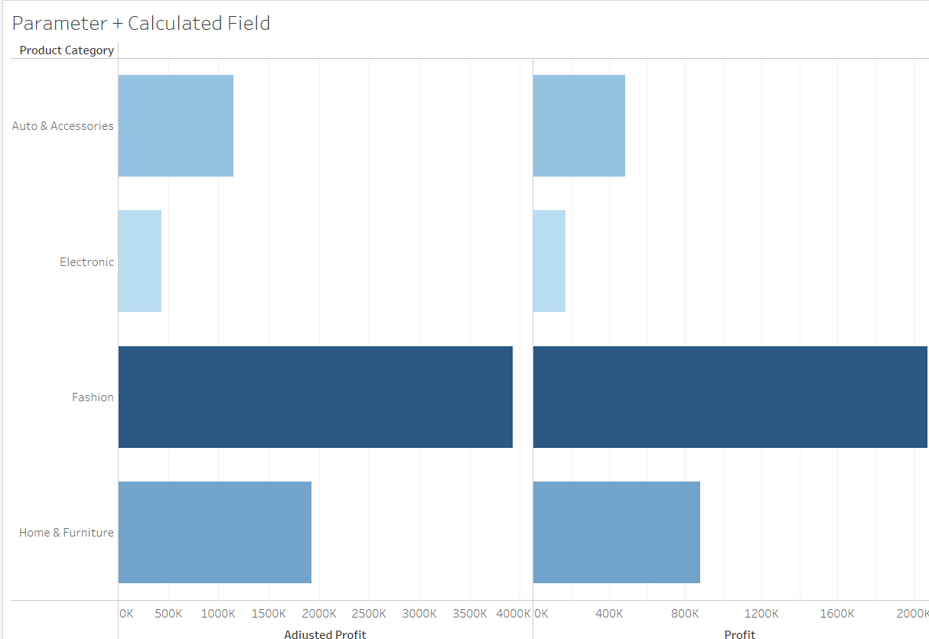
• Reveals impact of hypothetical business changes or scenarios (parameter adjustments) on profit margins across categories.
• The "Fashion" category remains dominant even after parameter adjustments, emphasizing resilience and importance.

- Time Chart:
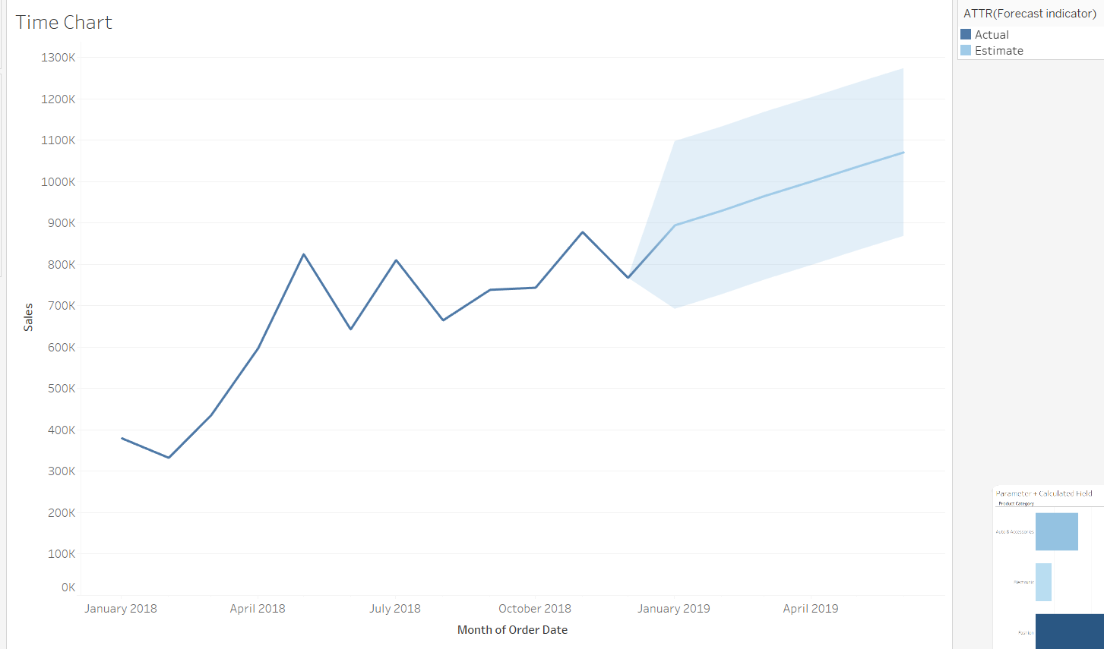
• Sales have a positive upward trend with moderate seasonal fluctuations.
• The forecast suggests consistent growth, indicating a positive outlook for future sales strategies and inventory management.
- Drill-Down View (Sales by Product):
• Highlights best-selling products indicating strong market preference and sales opportunities.
• Identifies lower-selling products suggesting potential reevaluation of product strategies or marketing efforts.

Part 4: Dashboard Overview
- 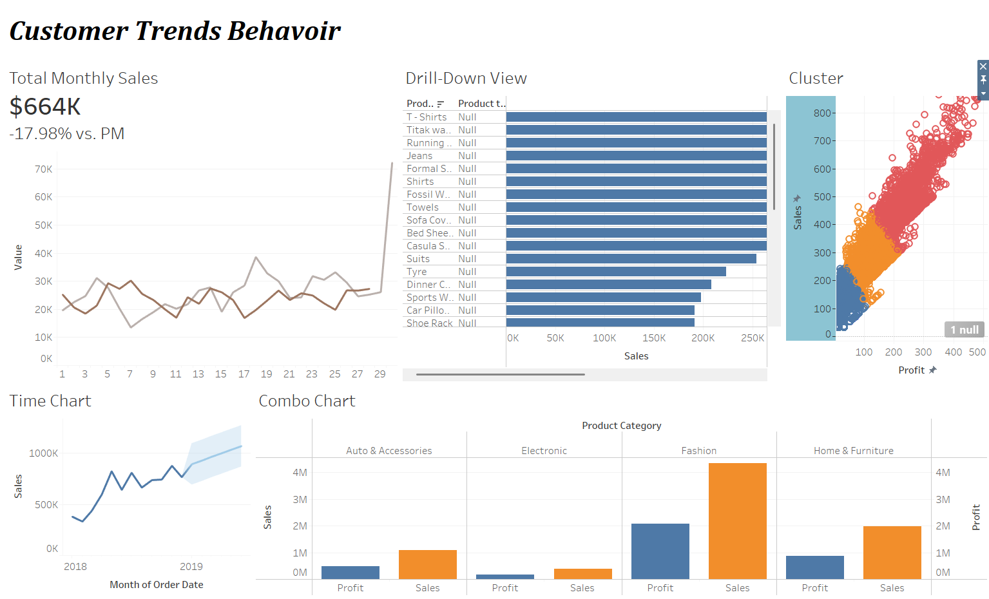
- Navigation Logic:
- Page 1: Performance Overview
  - Includes KPI cards to provide quick insights into Total Sales, Total Profit, and Discounts, chosen for their relevance in rapidly assessing overall business health and operational efficiency.
  - Highlights key trends through visualizations like combo charts comparing Sales and Profit clearly.
- Page 2: Strategic Opportunities
  - Focused on detailed customer segmentation (Cluster Chart) and interactive what-if scenarios through parameter-driven simulations.
  - Designed to explore potential business actions and customer behavior in detail.

-KPI Used and Why:
• Total Sales: Direct measure of market performance and growth trajectory.
• Total Profit: Crucial for understanding overall business viability and operational effectiveness.
• Discounts: Provides insight into promotional strategies' effectiveness and impact on profitability.

-Storytelling Approach:
The text describes a visually appealing and organized data visualization tool, featuring neutral colors and selective highlights, a clean layout, dynamic filters for user-driven exploration, and a well-defined narrative flow from performance trends to strategic insights, promoting ease of comprehension and decision-making.
-Layout Explanation
The dashboards' clear, dual-page structure supports effective storytelling:
- Page 1 (Performance Overview): Offers executives immediate performance visibility with summarized KPIs and trend visuals.
- Page 2 (Strategic Opportunities): Facilitates deeper analysis through customer segmentation visuals and interactive simulations for strategic planning.
Clear labels, consistent formatting, and purposeful interactivity ensure executives quickly understand key insights, facilitating timely and informed decisions.

Part 5: Project Conclusions
- Key Findings:
The company should prioritize the fashion category by investing in marketing campaigns and promotional activities. They should also optimize their electronics strategy by reviewing pricing strategies and supplier contracts. They should implement targeted discount initiatives in moderate-performing segments to drive volume without sacrificing margins.
- Reflection: This project sharpened my ability to clean and analyze data using Python, while Tableau helped me translate insights into compelling visual stories. One major challenge was aligning messy transaction data with clear business questions — but with persistence and iteration, I developed a structured, decision-focused dashboard. I’ve strengthened both my technical and business communication skills, which will be critical in real-world data-driven roles.

